ISS Clapham
Transport

“The Gum-e® is at the cutting edge for cleaning equipment. Its significant advances in quality and safety fully justify the spend.”

quality and safety fully justify the spend.”
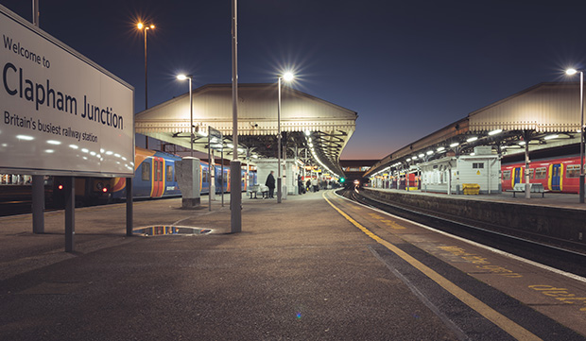

Founded in 1901, ISS is one of the largest facilities service providers in the world, employing over 535,000 people.
ISS manage everything related to facilities, including cleaning, support services, catering and security. Their contract to clean train carriages on behalf of Network Rail is just one of a number they operate in the rail sector.

THE CHALLENGE
The previous method, which did not always produce the desired outcome, was to apply a gum removal chemical to the surface, leave it for 5 minutes and return to scrape for up to 2 minutes. This process was time consuming and could only be used on floors, not seating which ultimately had to be replaced.

THE SOLUTION
Health & Safety approved
The Gum-e® meets H&S guidelines. It has no trailing leads, is portable and lightweight, and is safe to use. Unlike other machines on the market, there is no need to scrape with sharp tools, there are no harsh chemicals and none of the risks associated with high pressure steam or the use of gas cylinders.
Increases productivity
Steam is produced almost immediately with no time wasted waiting for it to warm up. Each piece of gum takes only seconds to remove, ensuring that it can
be removed from carriages within the tightest of turnaround times.
No marks on upholstery
The steam and vapour break the gum down, so it can simply be brushed or wiped away from carpets and seat upholstery.

The Gum-e® is effortlessly simple, yet incredibly powerful. Using it gives us close to a 50% time saving compared to conventional methods.

THOMAS COLLINS,
ACCOUNT DIRECTOR,
ISS FACILITY SERVICES UK

